INTERNSHIP REPORT

COMPANY: Net Avenue Technologies
ROLL: Web Developer
In day one had a interaction with the team and explored the Cbazaar website ,it’s an e-commerce website and learned new tags they used in website. Then did a software testing in Manual and solve the problems that are identify.

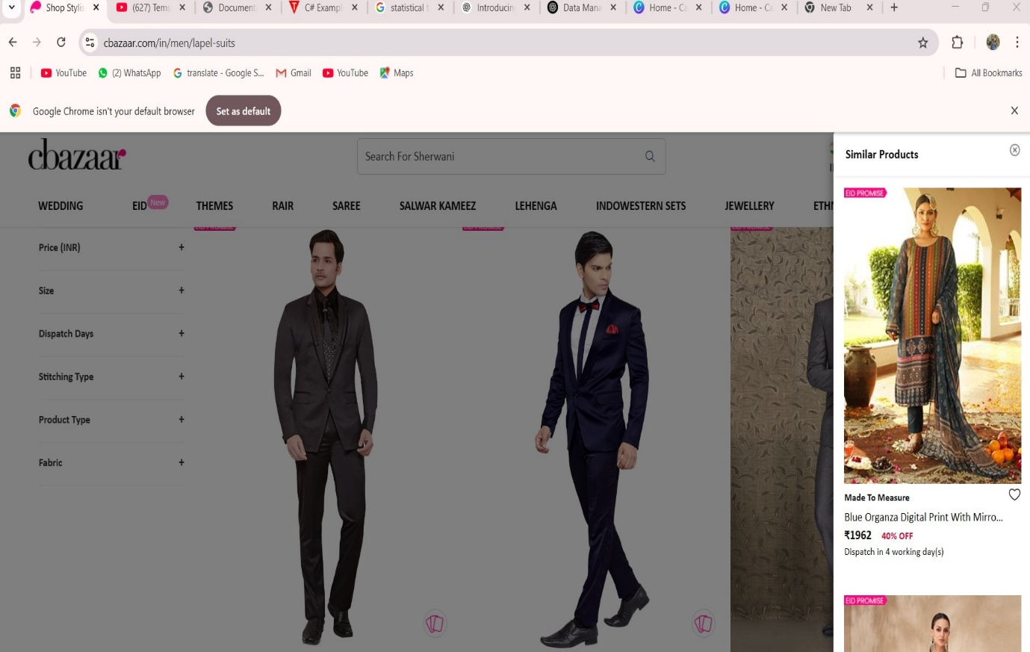
Fg.no:1

In software testing I identify the problem in the website, that showing a similar product has a error of showing different product that does not relate the product.

In second day I created a wireframe for my project and learned the work flow for the project. Then I created website outlook with 6 pages with detailed information, and had a brainstorming with the co-works related to this project and I got some new ideas ,then found that some related project done by “ZOHO”
IMS project for inventory purpose.

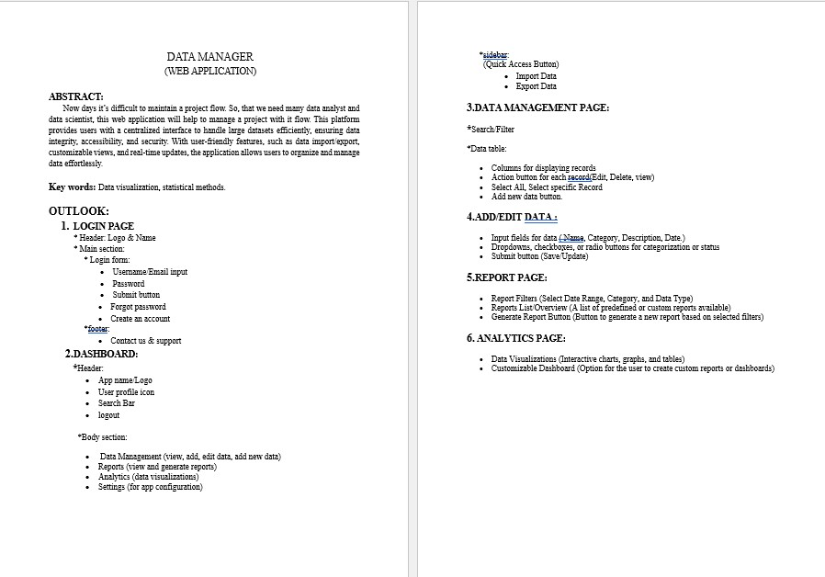
Fg.no:2
Then I started to learn some HTML and CSS program ,then I started to create website that related to MARVEL based theme , first I created a login page and reset password page.
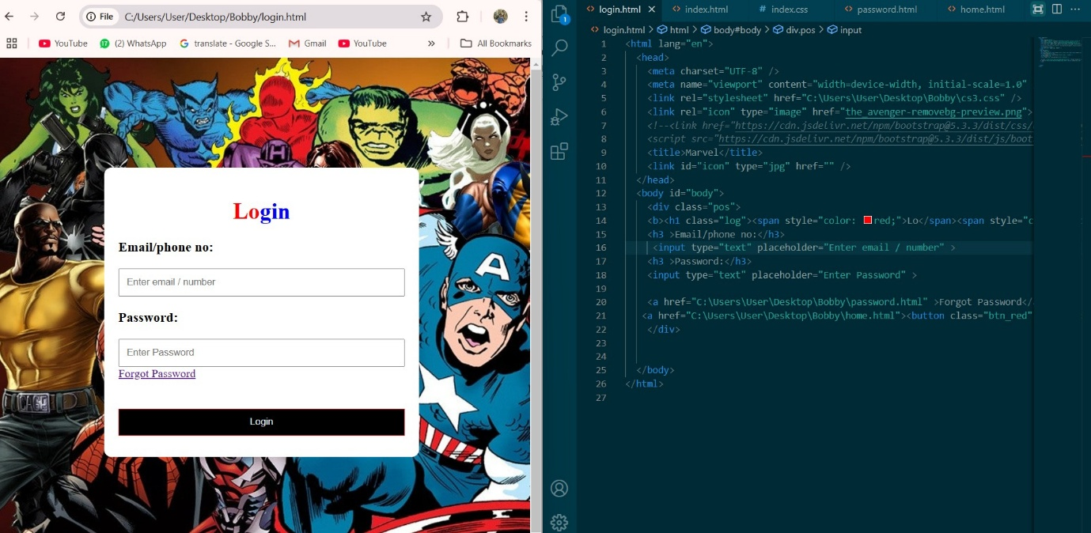
Fg.no:3

